FIT5125: IT Research and Innovation Methods
Assignment 2 (Task-B Report)
Name: Bharath Arun Gandhimani Student ID: 35501308

Hypothesis
Participants who report higher expressiveness scores (Expressiveness_Avg) will engage with a significantly greater number of unique people (Unique_People_Spoke_To) during collaborative sessions. This relationship, analyzed while controlling for age group and first language, tests whether communication style broadens conversational reach in the Kluster Networking Challenge system.

Null Hypothesis
There is no significant relationship between participant expressiveness and the number of unique people spoken to, after adjusting for age group and first language.

Variable Identification
- Independent variable: Expressiveness_Avg (self-rated, scale 1–5)
- Dependent variable: Unique_People_Spoke_To (count per participant)
- Confounders: Age_Range (categorical), First_Language (categorical)

Interpretation & Graph Annotations

Figure 1: Expressiveness scores are concentrated in [2.8,3.0) (n=141); overall distribution is symmetric and mid-centered.

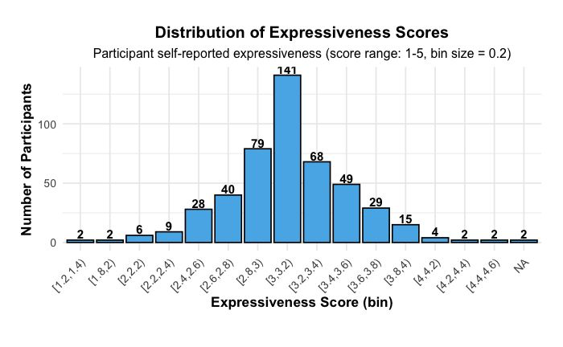

Figure 2: Most participants (n=95) spoke to 0–3 unique people, and only a handful reached higher bins.
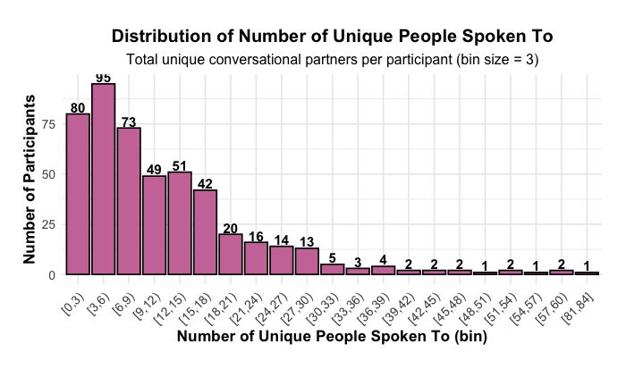

Figure 3: The positive linear regression band highlights that increases in expressiveness correspond to higher diversity in conversation partners.
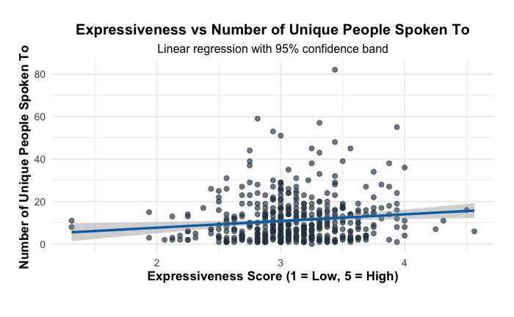
Figure 4: Diagnostics check for the linear model exposes the need for a negative binomial fit due to outliers and skew.
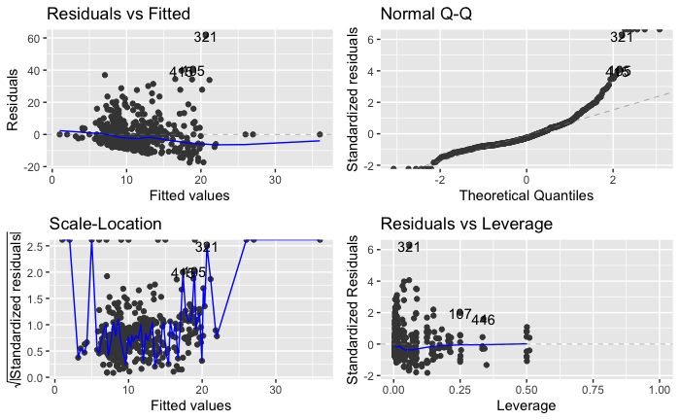

Statistical Approach
The analysis began by examining the distributions of expressiveness and unique contacts with two histograms (Figures 1 and 4). Expressiveness scores are nearly normal, peaking at 141 participants in the 2.8–3.0 bin, with labels above each bar for clarity. However, the count of unique people spoken to is heavily right-skewed, most commonly 95 participants spoke to 0–3 people, confirming innate count-data characteristics (Figure 4).
Analysis followed a systematic progression from data exploration to robust inferential statistics. Visual assessment began with histograms for both variables. The "Distribution of Expressiveness Scores" histogram (Figure 1) shows the highest frequency (n=141) in the [2.8,3.0) bin, indicating the majority rate themselves near the midpoint for expressiveness. The "Distribution of Number of Unique People Spoken To" (Figure 2) reveals a strong right skew: the [0,3) bin contains 95 participants, with bar labels showing exactly how frequencies steadily decline up to the [81,84) bin.
Scatterplot analysis (Figure 3) overlays a regression line, revealing a visible positive association between expressiveness and unique people spoken to, with the regression band illustrating the model fit. Regression diagnostics (Figure 4) from the linear model showed outliers and deviations from normality in residuals, confirming the need for robust count-data models.
Statistically, three models were tested: linear regression (for initial interpretability), Poisson (for count data), and, ultimately, negative binomial, as justified by high observed overdispersion (parameter ≈8.44) in Poisson results. Model selection and control for confounds was thus strongly driven by distributional evidence from the graphs themselves, supporting reliable and transparent results.

Statistical Results
Negative binomial regression found Expressiveness_Avg to be a statistically significant predictor of Unique_People_Spoke_To (estimate = 0.2005, standard error = 0.0958, z = 2.092, p = 0.0364). Neither age group nor first language reached significance at p < 0.05. These output values directly match the model summary.
Linear regression suggested significance (estimate = 2.699, p = 0.0243), but was undermined by visible right skew/outliers in the diagnostic panel (Figure 4). Poisson regression was significant (estimate = 0.2501, z = 6.96, p < 0.001) but highly overdispersed, with a calculated dispersion parameter of 8.44. The AIC for the negative binomial model was 3259.1 and theta estimate was 1.776.
The annotated scatterplot (Figure 3) makes this effect visually clear: as expressiveness increases, participants tend to interact with more unique contacts, while frequency-labeled histograms (Figures 1 and 2) provide exact sample context.

